For those interested in the trip to Australia:
As most of you know, We returned from Australia on Thursday Jan 25th. We went to David's bother John's wedding in Adelaide. We got to feed to Roos and Koalas. Even got to hold them. Saw all sorts of wierd animals and some normal and cute ones too. We saw Sea Lions and Fur Seals, Penguins, and Pelacans that ran right over my shoe to name a few. I went knee boarding behind a really nice ski boat on the river Murry. Probably have 400 or more pictures if anyone is interested in seeing more.

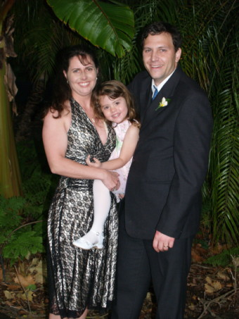
At John and Amy's wedding

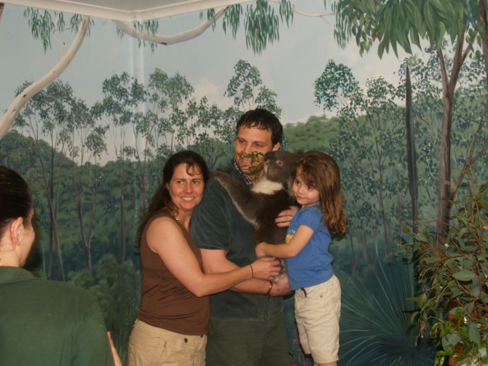
The Koala's name is Arthur

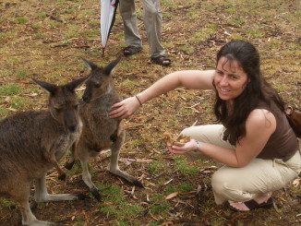
Young Roos whose friend Megan
is trying to catch (or chase)

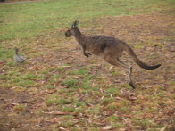
Imagine Megan running right behind

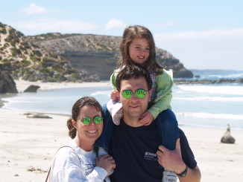
Sea Lions at Seal Bay

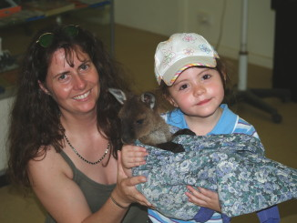
Woody the Joey whose mommy was run over by a car
Wanted to bring this one home.

